**September 25, 2023**

**Invitation to scoping workshop for CRA Amazon and Tropical Forests for Africa**

The Inter-American Institute for Global Change Research (IAI) and the São Paulo Research Foundation (FAPESP) are co-leading a new Belmont Forum funding Collaborative Research Actions (CRA) entitled “The Amazon and Tropical Forests: Its Global Implications and Needed Urgent Actions.”

We are pleased to invite you to participate in the scoping workshop to expand the dialogues to the African Tropical Forests. Our goal is to jointly identify the transdisciplinary research priorities that will become the basis of this CRA.

The workshop will be hosted in partnership with the Congo Biotropical Institute, the [French National Research Agency - ANR](https://anr.fr/en/), START International, and Future Earth Africa Hub, on **Tuesday, October 10th** at **14:00-16:00 ACT** (08:00-10:00 EST/12:00-14:00 UTC), in a virtual format. To join the workshop please register in this[**ZOOM LINK**](https://us06web.zoom.us/j/82845689426?pwd=dHRwzTA44wEC8mI0DsYJsxT4ckH7Ic.1) (Meeting ID: 828 4568 9426; Code: 553349). Please find below the Agenda for the workshop.

We highly appreciate your active participation in this important workshop.

Best regards,

***Inter-American Institute for Global Change Research (IAI)***

***São Paulo Research Foundation (FAPESP)***

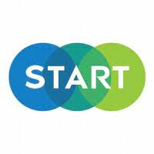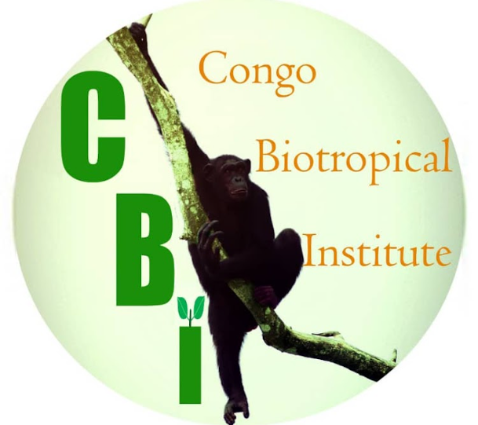



**Belmont Forum Collaborative Research Action**

**Amazon and Tropical Forests; its global implications for a sustainable future**

**Africa Scoping Workshop**

**Tuesday, October 10th, 14:00-16:00 ACT/08:00-10:00 EST/12:00 - 14:00 UTC**

**Background**

The Inter-American Institute for Global Change Research (IAI) and the São Paulo Research Foundation (FAPESP) are co-leading a new Belmont Forum Collaborative Research Action (CRA) entitled, “The Amazon and Tropical Forests: Its Global Implications and needed urgent actions”. The CRA recognizes the growing threats to tropical forests and their inhabitants such as climate change, deforestation, unregulated agriculture, illegal wildlife trade, and water contamination. In many places, the well-being and survival of indigenous peoples and local communities depend on the local ecosystem under threat. The challenges faced by tropical forest regions vary depending on governance, local ecology, cultural diversity, and territorial configuration. Therefore, the CRA envisions integrating the knowledge of the Amazon region and other Tropical Forests and all their functions—including the socioeconomic and environmental processes—to identify and implement measures to sustain and conserve the livelihoods of communities living in Tropical Forests worldwide. Previous scoping activities for this CRA highlighted the importance of topics related to environmental justice, and environmental governance frameworks protecting knowledge and practices of indigenous and local communities embodying traditional lifestyles relevant to the conservation and sustainable use of biological diversity.

The transdisciplinary approach is transversal to all stages of the call and project development; therefore, this workshop aims to expand the scoping discussions to African countries to include their concerns related to regional and worldwide Tropical Forests. This workshop will be hosted in partnership with the Congo Biotropical Institute, the [French National Research Agency - ANR](https://anr.fr/en/), START International, and Future Earth Africa Hub.





**Workshop Objectives**

This Scoping Workshop aims to bring together experts from different fields and backgrounds, different societal partners, governments, and civil society organizations from Africa to jointly identify research priorities for African and worldwide Tropical Forests, that will become the basis of the CRA. The session will be a guided open dialogue with participants to jointly identify research priorities for Tropical Forests from the African perspectives.

**SCOPING WORKSHOP AGENDA**

**Lien Zoom:** [Meeting Registration - Zoom](https://us06web.zoom.us/meeting/register/tZYlc-yupjIuGNIZYGVyiNagpV-i-UykMk58?_x_zm_rtaid=m1EChJlvTHqWmXlfFdIpOw.1696213201624.d26fea9b299bb16c03cb97d3ea5b897a&_x_zm_rhtaid=578#/registration)

|  |  |
| --- | --- |
| **UTC** | **Item** |
| 12:00 - 12:05 | Welcome and opening: Objectives of the Workshop |
| 12:05 - 12:10 | Belmont Forum overview |
| 12:10 - 12:20 | Lead agencies overview   * IAI * FAPESP |
| 12:20 - 12:25 | Overview of the CRA: Science background and timeline |
| 12:25 - 12:35 | Keynote Speaker 1: “The Critical Importance of African Tropical Forests for Socio-Ecological Systems”  Dalley-Divin SAA-SITA, Congo Biotropical Institute CBI, Democratic Republic of Congo |
| 12:35 - 12:45 | Keynote Speaker 2: ANR expert (TBC) |
| 12:45 - 13:15 | Breakout Groups   * What are the transdisciplinary research priorities for African Tropical Forests (e.g., topics, regions, approach)? * What are the global implications of those research priorities? |
| 13:15 - 13:20 | Health break |





**SCOPING WORKSHOP AGENDA**

|  |  |
| --- | --- |
| **UTC** | **Item** |
| 13:20 - 13:40 | Breakout Groups   * How can we engage with African funders and partners in this funding call? Who can be brought into the discussion? (Provide contacts of those institutions) |
| 13:40 - 13:55 | Breakout groups report and comments |
| 13:55 - 14:00 | Concluding remarks |

* The workshop will have an English/French interpretation



