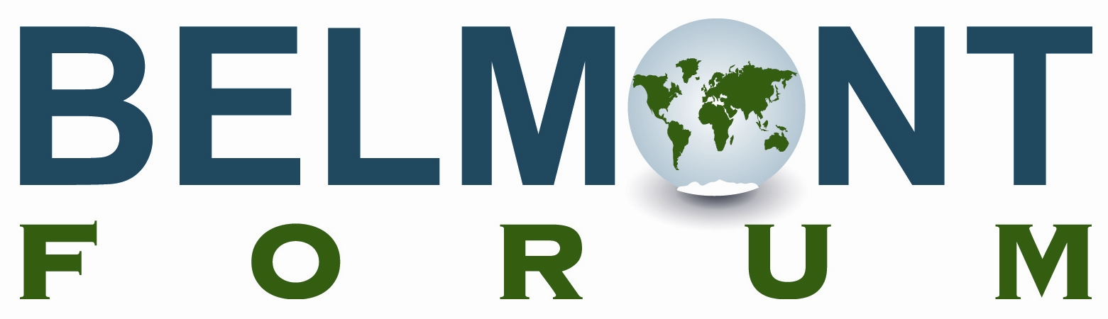

Arctic Collaborative Research Action
Second Scoping Workshop

Arctic Observing Summit, Vancouver, Canada, Hyatt Regency Hotel

Draft Agenda

• Included documents, distributed prior to May 1st:

Minutes from first scoping workshop
Actions identified by Delhi meeting of Belmont Forum
Draft solicitation document prepared by US, Canada, and Norway

May 1st, 12h30-13h30 PT – Room to be announced at conference venue

Introductions by interested participants

Discussion of main themes: interdisciplinary Arctic observing and Arctic sustainability science

Feedback regarding current activities in these areas, including national or agency priorities

May 2nd, 12h30-13h30 PT – Room to be announced at conference venue

Discuss potential mechanisms for linking ongoing activities and instigating new projects under Belmont

Provide comments on draft solicitation document

Determine action items and national/agency points of contact for drafting

